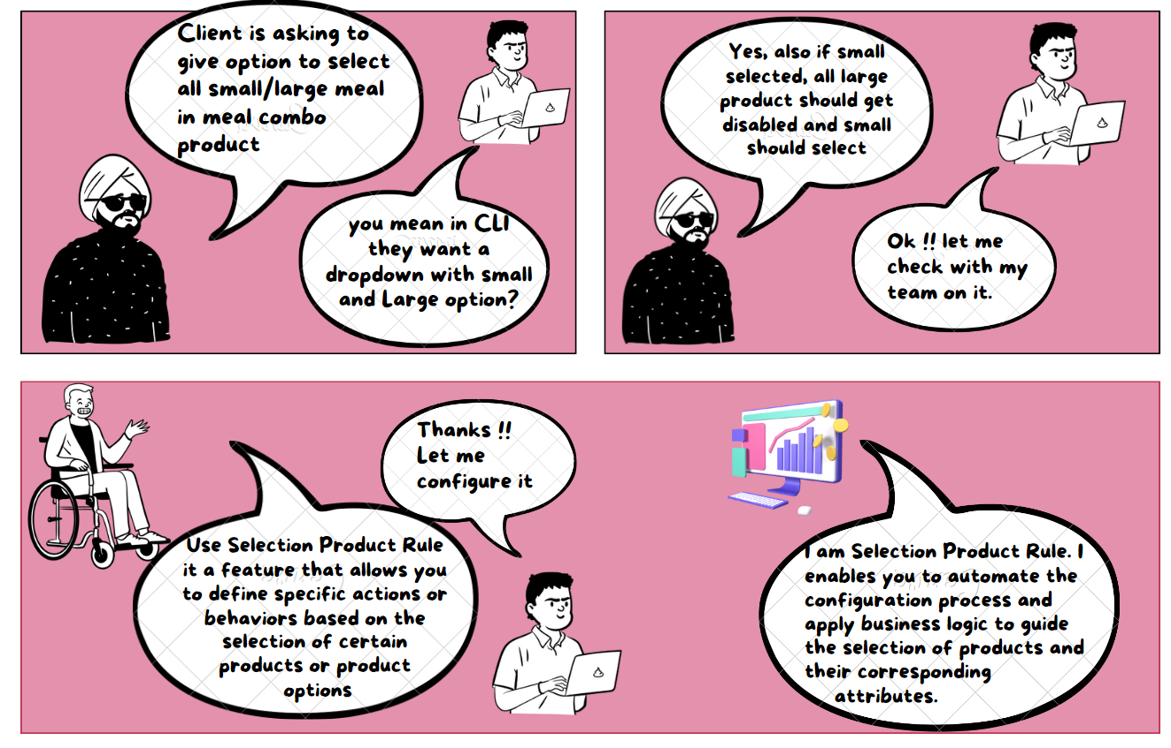

**Selection Product Rule:**

Selection Product Rule in Salesforce CPQ is a feature that helps automate product selection and configuration. It allows you to set up specific actions based on the choices made by a customer when selecting products or options.

**Type of Selection Product Rules:**

Salesforce CPQ provides several actions out of the box, such as Enable, Disable, Add, Remove, Show, and Hide. Based on the requirements, these actions can be selected in the Type field. All possible options are given here-

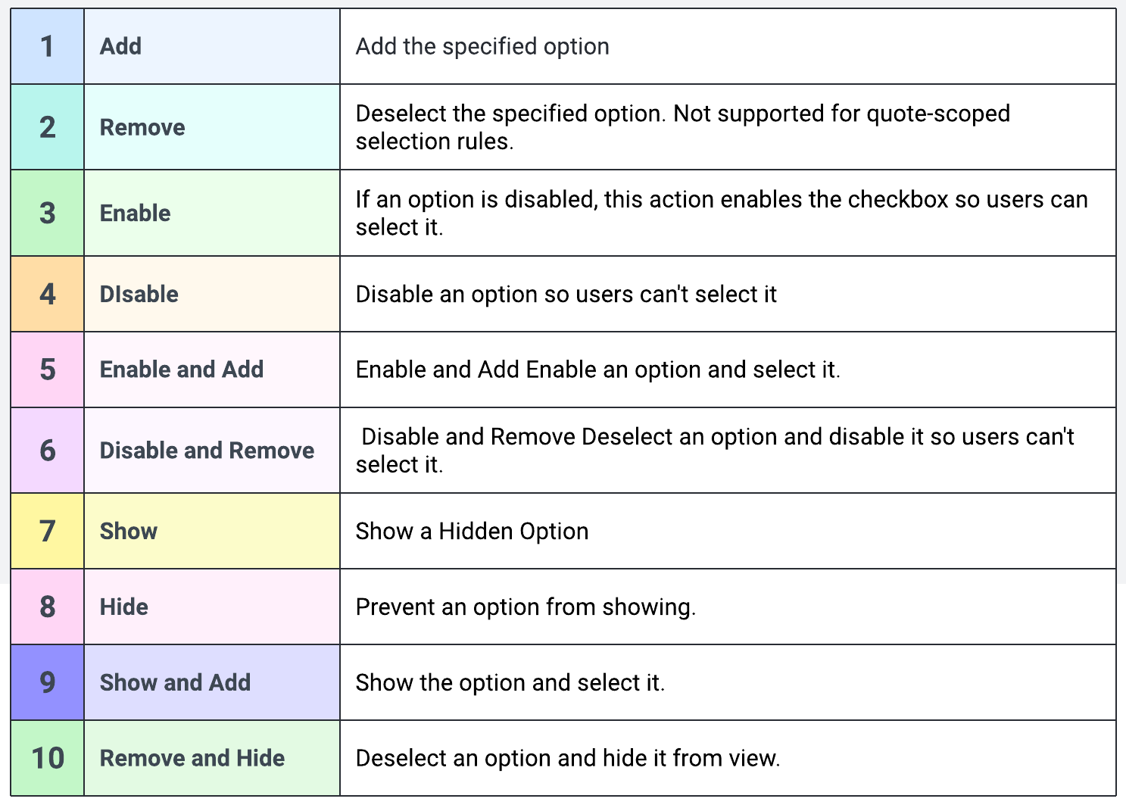

Here's an explanation of how it works:

1. **Conditions**: You can define certain conditions that must be met for the rule to be triggered. For example, if a customer selects Product A, you can specify that a particular action should happen.
2. **Actions**: Once the conditions are met, you can determine what actions should take place. These actions include adding or removing products, changing quantities, adjusting prices, or modifying other attributes. The system automatically performs these actions when the conditions are satisfied.
3. **Order of Execution**: The rules are processed in a specific order that you set. This ensures that the rules are applied correctly and in the desired sequence. Controlling the order can create more complex logic by combining multiple rules.
4. **Nested Rules**: You can also have rules within rules, which means you can build more advanced logic. This allows you to handle complex scenarios by combining different conditions and actions.

**Steps to Configure Product Rule:**

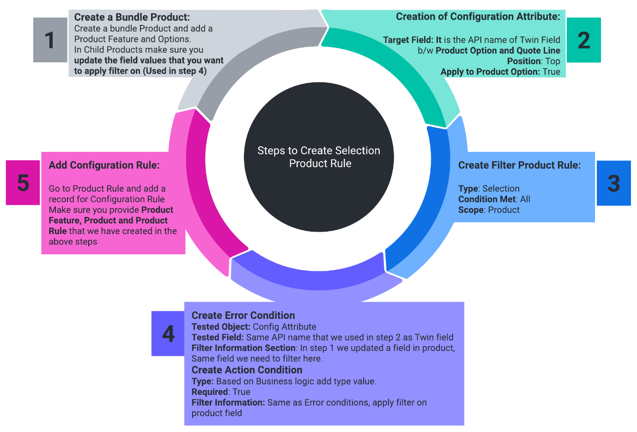

**Use Case:** In the PVR Meal combo product, Now based on the selection of Configuration attribute (Meal Size) we want the product of the same size to be selected and all other features of other sizes should not show in the QLE.  

Let's check the steps -

1. **Create a Bundle Product:**  
   In the bundle product PVR Meal Combo, we need to separate each child product by its size - Small and Large. Let's check the steps -
   * Create a Picklist Field on the Product object - Size, with 2 values - Small and Large
   * Go to all child Products and update the size accordingly.
2. **Creation of Configuration Attribute:**
   * Go to the Bundle Product and click on Related
   * Click on the New button under Configuration Attribute
   * **Attribute Name**: Meal Size Small
   * **Target Field**: Meal_Size__c
   * **Postion**: Top
   * **Apply To Product Option**: True
   * **Create Twin Field (Meal_Size__c):**Go to Object - Product Option - Field and Relationships - Click on New button and Create a picklist field Meal_Size__c. Give Small and Large as picklist values. Follow the same steps and create a field in Quote Line as well. Make sure the API name is the same.
3. **Create Filter Product Rule:**
   * **Type**: Selection
   * **Scope**: Product
   * **Evaluation Event:** Always
4. **Create Error Condition:**
   * **Tested Object:** Configuration Attribute
   * **Tested Field:** Meal_Size__c ( Twin Field that we have created in the above step)
   * **Operator**: equals
   * **Filter Type**: Value
   * **Filter Value**: Small
5. **Create Error Actions:**
   * **Type**: Add
   * **Required**: True
   * **Filter Field**: Size__c ( This is product object field)
   * **Operator**: equals
   * **Filter Value**: Small  
     Create another Filter action.
   * **Type**: Hide & Remove
   * **Required**: True
   * **Filter Field**: Size__c ( This is product object field)
   * **Operator**: not equals
   * **Filter Value**: Small
6. **Add Configuration Rule:**Go to Product Rule and add a record for Configuration Rule Make sure you provide Product Feature, Product, and Product Rule that we have created in the above steps

Now let's test the Selection Product Rule. Go to the Quote and click on the Edit Lines button and add the PVR Meal Combo Product. Now click on Small. You will notice only products with Small values are showing -

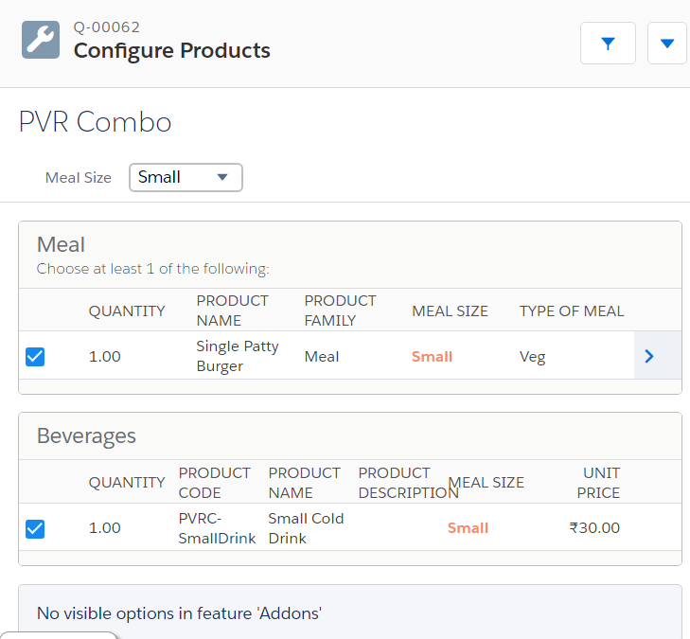

Interview Question:

1. What is the use of Configuration Attributes record?
2. What is the use of Product Rule record?
3. What is the use of Configuration Rule?
4. When would you use a Selection Product Rule in a CPQ implementation?
5. What object Product Configuration use to show target field? Can we change that object?
6. How Product and Product Rule are linked? / What is the relation b/w Product and Product Rule?
7. How we can validate/pass information from Product Configuration record to Product record?